**The concept:** fluxgate magnetometer and magneto-inductance sensors can be used to locate ferromagnetic materials by creating a magnetic field and sensing the small changes in field strength in response to exposure to external magnetic fields. Unlike non-ferromagnetic materials, ferromagnetic materials can be magnetized by a magnetic field and produce a measurable change in the applied magnetic field. Ferromagnetic materials typically contain resources that would be useful to future regolith-mining operations.

Before we can begin detailed design, there’s a lot of focused research to do to gauge the range of feasibility of a ferrous resources (or possibly also other metallic resources) finder. This is the list of topics that need to be explored. If you’d like to call soft dibs on a topic, put your name by it.

1. **Market search: fluxgate magnetometer and magneto-inductance sensor tech availabilities and limitations - Aila**

List commercial options that can fit in the prescribed max payload volume, and can operate in the lunar environment (e.g. consider temperature ratings)

* Bartington produces some high-temp small fluxgate magnetometers

What specifications are most relevant to determining a sensor’s strength and sensitivity? (These will be the values used in calculations to determine stuff like the smallest particle size sensable by a given sensor)

* Measurement/Sensing Range

What are the electrical operation requirements (current, voltage, power consumption) for each sensor option?

Are there any other sensor types for sensing very small magnetic fields/very small changes in magnetic field?

Are there any other ways to detect ferromagnetic materials, besides magnetism, that could be reasonably implemented in a small payload size?

**Selected the Xtrinsic magnetometer:** <https://www.nxp.com/docs/en/data-sheet/MAG3110.pdf>

1. **What do scientists currently know about distribution of ferromagnetic materials on the moon? - Scott**

(Iron, nickel, and cobalt are known to be ferromagnetic)

What ferromagnetic materials are known to be on the moon? What are the values of their magnetic susceptibilities and permeabilities (material properties that are used in calculations)?

Table 1: Magnetic Susceptibilities by mol (Xmol), mass (Xmass), and volume (Xv) of various metals

|  |  |  |  |  |  |  |  |  |  |  |
| --- | --- | --- | --- | --- | --- | --- | --- | --- | --- | --- |
|  | ***Temp*** | ***Pressure*** | ***Molar susc.***  ***χmol*** | | ***Mass susc.***  ***χmass*** | | ***Volume susc.***  ***χv*** | | ***Molar mass***  ***M*** | ***Density***  ***ρ*** |
| ***(°C)*** | ***(a***[***tm***](https://en.wikipedia.org/wiki/Atmosphere_(unit))***)*** | ***SI***  ***(m3/mol)*** | ***CGS***  ***(cm3/mol)*** | ***SI***  ***(m3/kg)*** | ***CGS***  ***(cm3/g)*** | ***SI*** | ***CGS***  ***(emu)*** | ***(10−3 kg/mol***  ***= g/mol)*** | ***(103 kg/m3***  ***= g/cm3)*** |
| Aluminium |  | 1 | +2.2×10−10 | +1.7×10−5 | +7.9×10−9 | +6.3×10−7 | +2.2×10−5 | +1.75×10−6 | 26.98 | 2.70 |
| Silver | 961 | 1 |  |  |  |  | −2.31×10−5 | −1.84×10−6 | 107.87 |  |
| Bismuth | 20 | 1 | −3.55×10−9 | −2.82×10−4 | −1.70×10−8 | −1.35×10−6 | −1.66×10−4 | −1.32×10−5 | 208.98 | 9.78 |
| Copper | 20 | 1 |  |  | −1.0785×10−9 |  | −9.63×10−6 | −7.66×10−7 | 63.546 | 8.92 |
| Nickel | 20 | 1 |  |  |  |  | 600 | 48 | 58.69 | 8.9 |
| Iron | 20 | 1 |  |  |  |  | 200000 | 15900 | 55.847 | 7.874 |

Table 2: Permeability (absolute and relative) of various substances

|  |  |  |
| --- | --- | --- |
|  | **Permeability ( *µ ) (H/m)*** | **Relative permeability ( *μ / μ0* )** |
| Air | 1.25663753 10−6 | 1.00000037 |
| Aluminum | 1.256665 10−6 | 1.000022 |
| Bismuth | 1.25643 10−6 | 0.999834 |
| Cobalt-Iron (high permeability strip material) | 2.3 10−2 | 18000 |
| Copper | 1.256629 10−6 | 0.999994 |
| Ferrite (nickel zinc) | 2.0 10−5 – 8.0 10−4 | 16 – 640 |
| Ferritic stainless steel (annealed) | 1.26 10−3 - 2.26 10−3 | 1000 – 1800 |
| Iron (99.8% pure) | 6.3 10−3 | 5000 |
| Iron (99.95% pure Fe annealed in H) | 2.5 10−1 | 200000 |
| Neodymium magnet | 1.32 10−6 | 1.05 |
| Nickel | 1.26 10−4 - 7.54 10−4 | 100 – 600 |
| Platinum | 1.256970 10−6 | 1.000265 |
| Vacuum ( µ0 ) | 4π 10−7 | 1 |
| Water | 1.256627 10−6 | 0.999992 |

What ferromagnetic materials can be used for useful things (e.g. iron ore can obviously be refined - what other specific ferromagnetic materials could NASA be interested in and how)?

*The three most common magnetic metals are iron, nickel, and cobalt. As shown in Figure 1, iron is the only one measured in considerable quantities on the lunar surface.*

*Uses for each of these three:*

*Iron: manufacturing parts through powder metallurgy techniques*

*Nickel:*

What is the distribution of these materials? Do we know if they ever occur in relatively concentrated deposits, or do they instead occur spread out over a large area?

*The lunar highlands contain greater amounts of calcium, aluminum, silicon, and oxygen. The lunar maria (seas) contain basalt lava flows, which consist primarily of:*

* *Anorthite CaAl2Si2O8*
* *Orthopyroxene (Mg,* ***Fe****)SiO3*
* *Clinopyroxene Ca(Mg,* ***Fe****)Si2O6*
* *Olivine (Mg,* ***Fe****)2SiO4*
* *Ilmenite* ***Fe****TiO3*

*Basalt is classified in accordance with its titanium concentration (see Figure 1).*

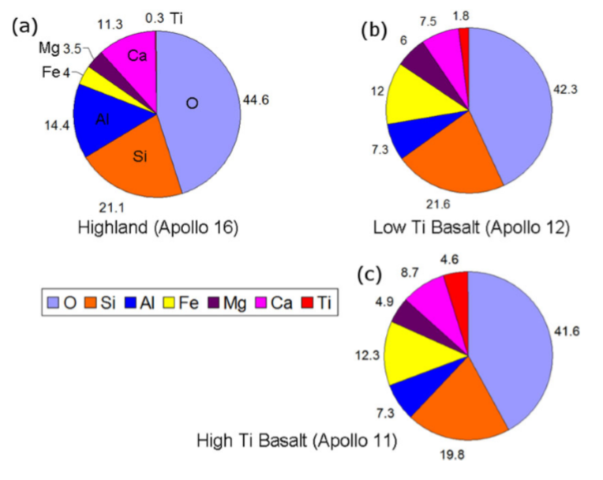

Figure 1: Mineral concentrations in different materials/regions on the Lunar surface.

*As Figure 1 shows, iron has a greater presence in the lunar maria (b,c) than in the highlands (a). The difference in concentration between Low Ti Basalt and High Ti Basalt is 0.3%, which may be negligible, unless we find a really easy way to locate high concentrations of titanium.*

*Although iron is most concentrated in basalt flows, it would also be energy-intensive to extract. Perhaps a more feasible source, therefore, would be iron in the regolith, despite the lower concentration. The regolithic iron has (at least) three sources:*

1. *meteoric iron*
2. *iron released from bedrock sources, and*
3. *iron produced by the reduction of regolithic iron oxide by solar wind hydrogen.*

*Source 3 would result in “nanometre sized blebs” that would be difficult to extract. Combined, Sources 1 and 2 contribute about 0.34 +/- 0.11 wt%.*

*The practical difficulty of extracting the iron will result from its size, which is generally less than 1µm. The article that I am reading suggests some sort of magnetic sieving technique to separate the tiny pieces of iron from the regolith.*

*Also, meteoric iron is often accompanied by nickel, platinum group metals (PGMs) and gold.*

*It has been theorized that prominent lunar magnetic anomalies indicate the crash sites of iron-rich meteorites (Source 1). The largest concentration of these magnetic hotspots is located at the northern rim of the South Pole-Aitken Basin (SPA), as shown in Figure 2.*

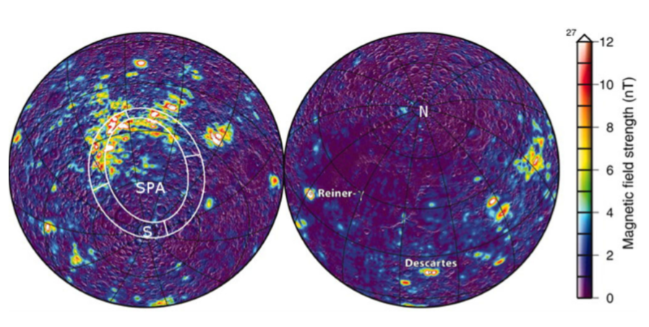

Figure 2: Magnetic anomalies on the lunar surface

*If we are able to choose the landing site for the payload, I would recommend aiming for this region, where we would likely have the highest chance of finding large concentrations of surface iron. This correlation between iron concentration and magnetic anomaly strength is ONLY A THEORY and could therefore be the subject of our mission.*

*We could send multiple identical iron-finding payloads to different regions with known magnetic anomaly strength. Then we would be able to contribute to the determination of whether Figure 2 could be used to locate large iron deposits elsewhere on the moon. In other words, we could help confirm or contradict the theory that magnetic anomalies represent regions of high iron concentration.*

Are deposits typically buried, or lying on the lunar surface?

1. **Ferri- and antiferromagnetism (**[**http://www.irm.umn.edu/hg2m/hg2m_b/hg2m_b.html#ferrimagnetism**](http://www.irm.umn.edu/hg2m/hg2m_b/hg2m_b.html#ferrimagnetism)**)**

Would ferrimagnetic and antiferromagnetic materials interact with an external magnetic field as strongly as the classic ferromagnetic materials?

**Ferromagnetic**

All magnetic moments aligned, therefore spontaneous magnetization

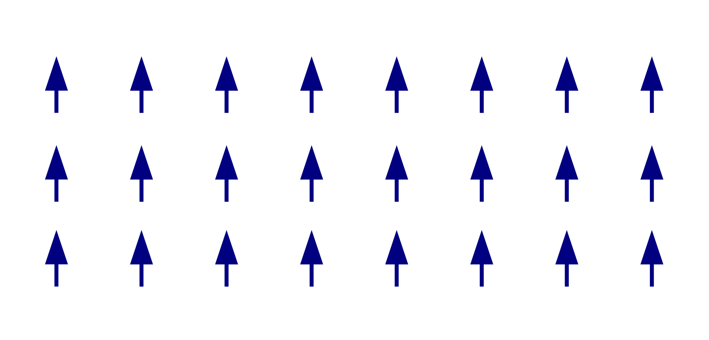

**Ferrimagnetic**

Some magnetic moments are oriented in the opposite direction, but have a smaller magnitude. Still has spontaneous magnetization.

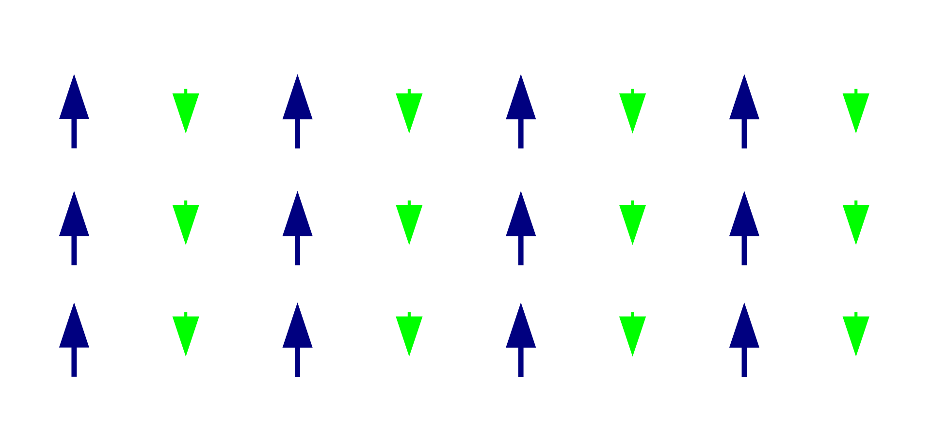

**Antiferromagnetic**

Opposing magnetic moments balance completely, therefore no spontaneous magnetization.

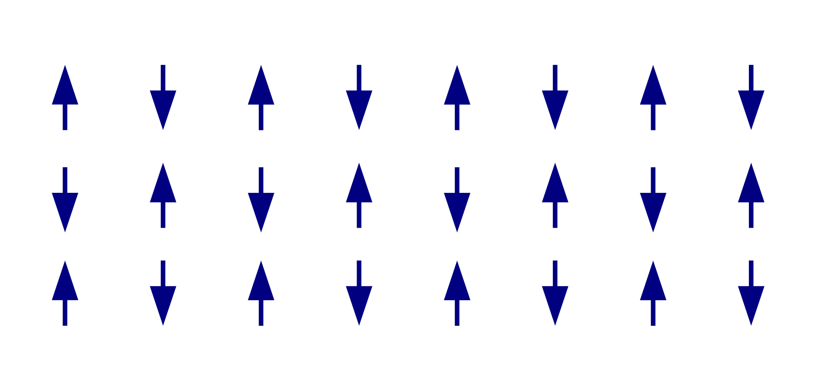

**Summary / Relevance**

Whichever method we choose will likely be totally or predominantly ineffective for detecting antiferromagnetic materials. Because both ferromagnetic and ferrimagnetic materials have spontaneous magnetization, they should both be detectable by our payload.

Ferrimagnetic can have some interesting interactions with microwaves: they can be used to build isolators, which only allow light to travel through them in one direction

If yes, what are some ferrimagnetic and antiferromagnetic materials that could be useful, do they occur on the moon, and if they do occur on the moon, in what abundance?

“Lunar Rock Magnetism” article: <http://adsabs.harvard.edu/full/1972Moon....4..160N>

*I’m going to read through this article tomorrow (24 May) and summarize the important stuff below.*

1. **Do the calculations and theory to determine viability of methods and to determine the minimum particle size that can be sensed by a given design - Kelsey**

HOW do magnetometers measure the field? Is there a limit on what field strength they can “sit” in? Does calibration mean that they’re calibrated to sense a particular field as “normal,”

* Email Application Engineer re: magnetometer calibration
* Email astronomy and/or physics profs about whether magnetic shielding idea is...good

What are some ways that fluxgate magnetometers can be used to sense ferromagnetic materials in the low-ambient-magnetic-field environment of the moon? How reliable is each method?

|  |  |
| --- | --- |
| **Method concept** | **Reliability** |
| Use the fluxgate magnetometer primary excitation field to create eddy currents in ferromagnetic materials that create a sense-able amount of magnetic drag | NOT reliable, very much not recommended |
| Use a strong permanent magnet to magnetize ferromagnetic materials, manipulate its field so it doesn’t fully magnetically saturate the F.M.’s core and ruin its operation, and use the F.M. to detect small changes in the field due to magnetized ferromagnetic particles | Reasonably likely reliable; **further research needed** to fully gauge and quantify reliability and determine how to implement idea |
| Same as above but with an electromagnet rather than a permanent magnet |

**Next steps**:

1. Read the Feynman Lectures [36](https://www.feynmanlectures.caltech.edu/II_36.html) and [37](https://www.feynmanlectures.caltech.edu/II_37.html) about ferromagnetism
2. Get a sense (either exactly or scale-of-magnitude) of how significantly ferromagnetic materials will warp magnetic fields in general
3. Get a sense of how powerful of a magnet or electromagnet would be needed to interact
4. Find a way to represent warpage mathematically
5. Derive expressions for magnetic field strength
6. Review section about magnetometer calibration: https://books.google.ca/books?id=0xwYNpQ0bnUC&pg=PA193&lpg=PA193&dq=instrumentation+company+fluxgate+magnetometer&source=bl&ots=-nA0snZeR8&sig=ACfU3U28PXmvT2HwGkw4i81hCH0AYR7Xww&hl=en&sa=X&ved=2ahUKEwiTtJ6JzMrpAhXZGDQIHV9GB7UQ6AEwCnoECBIQAQ#v=onepage&q=instrumentation%20company%20fluxgate%20magnetometer&f=false

Contact a prof (Poman So)

Once calculations have been figured out, record them neatly and officially per the UVic Rocketry calculation sheet guidelines (see *+UVR > 8 - Testing* folder), and upload to NASA mini payload folder

Also put together a spreadsheet in the NASA mini payload folder for automating subsequent calculations once calculations have been figured out

**How do fluxgate magnetometers work?**

* A basic fluxgate magnetometer uses one coil to induce a magnetic field in a core in the sensor (using an alternating current, Faraday’s Law kind of stuff), and a second coil that simple measures the current induced in it by the first coil’s magnetic field. An additional “DC bias” current is also applied to generate a constant (or alternating, depending on design) magnetic field that keeps the core in the saturated magnetized condition throughout the excitation field’s operation.

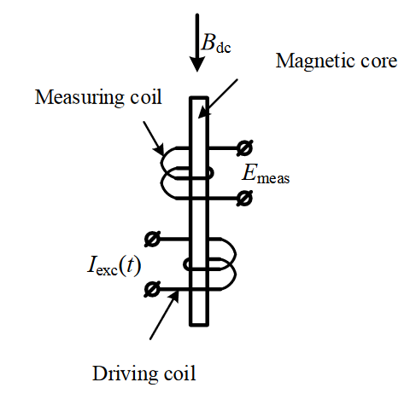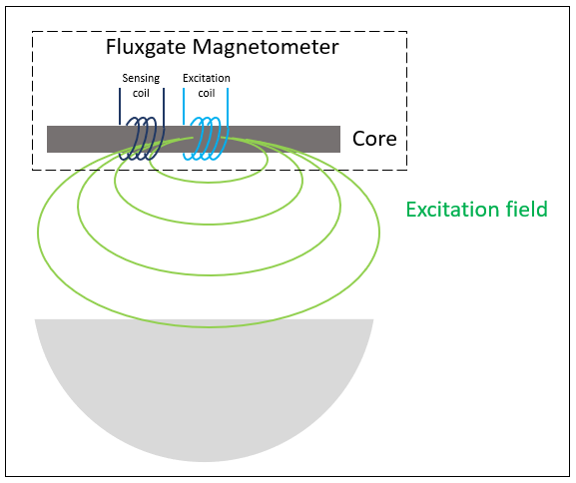

* 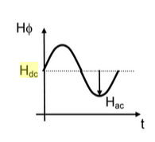How DC bias affects overall exciting magnetic field (<https://books.google.ca/books?id=WuacDwAAQBAJ&pg=PA30&lpg=PA30&dq=Magnetic+Sensors+and+Magnetometer+Hdc&source=bl&ots=ei7LLclymx&sig=ACfU3U3Y-I9tIqNRlsdJhfkSMEi0Fdc4Bw&hl=en&sa=X&ved=2ahUKEwjZ38uRhqrpAhWSvp4KHRk3BsMQ6AEwDXoECAkQAQ#v=onepage&q=Magnetic%20Sensors%20and%20Magnetometer%20Hdc&f=false>, page 30)
* When something ferromagnetic is put in sufficient range of the alternating exciting magnetic field, the exciting field induces eddy currents in the material, which in turn create their own magnetic fields that oppose the direction of the exciting field and create “magnetic drag” - essentially wonking up the exciting field such that the sensor coil will read a different current than it would normally.
* Mathematical model of a simple fluxgate magnetometer: <https://www.matec-conferences.org/articles/matecconf/pdf/2018/17/matecconf_se2018_01006.pdf>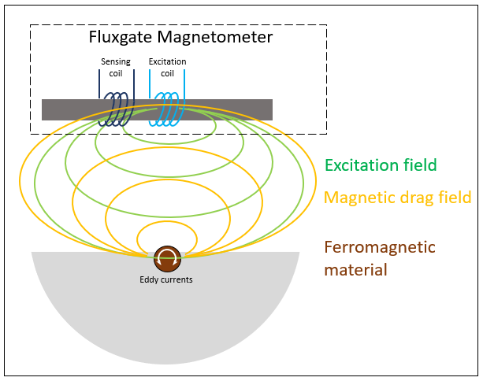
* Another Goole Books result describing magnetometer operation: <https://books.google.ca/books?id=8MuDDwAAQBAJ&pg=PA126&lpg=PA126&dq=dc+bias+fluxgate+magnetometer&source=bl&ots=SUagHU-Wsl&sig=ACfU3U3laevTH28A17PnTfYy_bgKMng-_g&hl=en&sa=X&ved=2ahUKEwidmYuIrazpAhXpIDQIHdaFAn0Q6AEwEnoECAsQAQ#v=onepage&q=dc%20bias%20fluxgate%20magnetometer&f=false>